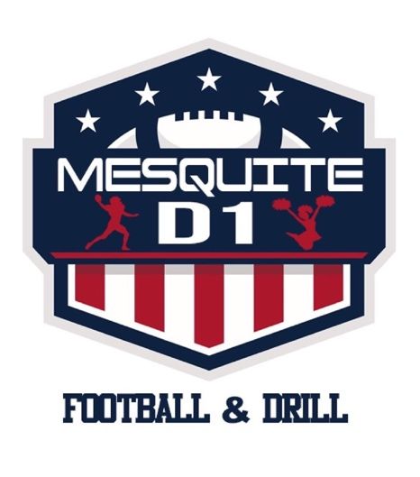

Mesquite Division 1 Football & Drill
Sponsorship Form

Mesquite Division 1 Football & Drill is a non-profit 501c3 organization who seeks monetary donations that will benefit the youth in North Texas. We use the funds to make improvements, contributions and scholarships for youth to participate in youth sports that will make a lifetime impact.

Please Fill out the form below and we will issue you tax form upon receiving the donation.

Amount Contributed:_____________________________________

Name of business or induvial:_____________________________
(how it appears on tax return)

Address to mail tax form:__________________________ City:________
State:___________________Zip Code:________________

